 

GCE/IAL applicable

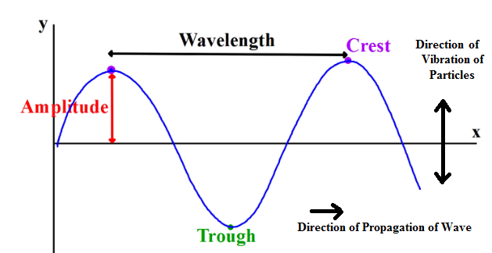

Unit 7 Current

I=vAnq:

Drift velocity (of electrons) increases (as current increases)

More (frequent) collisions of electrons with lattice ions

More energy transferred when electrons collide with lattice

Ions

Unit 8 Voltage and Power

Voltmeter high resistance:

(high resistance) so very little /negligible/zero current in the voltmeter, because that would change /increase the current in the ammeter.

Unit 9,10 IV characteristics

Ohm’s Law:

For metals at a constant temperature, the current in the metal is proportional to the voltage across it.

Unit 11 Internal resistance

Unit 14 Waves

P-wave:

Oscillations/vibrations of (air) particles/molecules/atoms

Oscillations/vibrations/displacement parallel to direction of propagation.

Unit 15 Transmission and reflection of waves

Polarization:

Plane of polarization of lens must be aligned at 90 degrees to plane of polarization of reflected light.

Diffraction:

Diffraction most when wavelength approximately equal to gap size

Unpolarised Light:

Oscillations/ vibrations in many directions

Polarised Light:

Oscillations/ vibrations in single direction

Oscillations/ vibrations are perpendicular to direction of propagation.

Optics

There is a change in density from water to air

Or there is a change in light speed from water to air

This causes a change in direction of light moving away from normal travelling from water to air.

So light appears to come from a different point of origin.

Diffraction:

High Frequency:

Higher frequency gives a shorter wavelength so there is less diffraction.

Shorter pulse duration:

Shorter pulses have a shorter length so allow great detail.

Separated by a shorter time interval:

Separated by a shorter time so the pulse travel a smaller distance and they return more quickly so to allow more frequent monitoring of the objects.

Unit 16: Interference of waves

Standing Waves:

antiphase, pi radian, superposition, interference, creating nodes and antinodes,

Waves superpose Or interference between two waves takes place,

In phase constructive Or Antiphase destructive,

Links to amplitude maximum Or amplitude zero respectively.

Diffraction Pattern:

Electron spread out, form a diffraction/ interference pattern or undergo superposition.

Electrons must behave as waves

Or electrons have a wavelength, similar to the atomic spacing

Because diffraction/interference is a wave behaviour.

Unit 17 Photo-electric effect

Photon:

Packet / package / quantum of electromagnetic energy.

Photo-electric effect:

Photons from incident light cause emission of electrons from surface of metal, and photon has energy E = hf. There is emission only if photon energy greater than or equal to Φ,

Φis the minimum energy required for emission of electrons ,½mv^2 is the kinetic energy of the emitted electron. It is max because some energy may be transferred to the metal.

Energy Difference: hf=E1-E2

Duality

Wave Theory of Light:

Diffraction occurs and fewer electrons emitted

Lower intensity of waves would provide less energy to release fewer electrons .Lower intensity would mean a longer time for sufficient energy to be absorbed for electron release.

Particle Theory of Light:

Fewer photons would release fewer electrons, write down photo-electric effect.